PROJECT DOCUMENTATION

​I can provide a filled-out documentation for the project named "Insightstream: Navigate the New Landscape" using the provided structure and content.

​Project Documentation: Insightstream

​1**. Introduction**

​***Project Title***: Insightstream: Navigate the New Landscape

​Team ID:NM2025TMID39304

Team leader: padmapriya.S [padmapriya96026@gmail.com](mailto:padmapriya96026@gmail.com)

​Team Members:

SUJATHA .V [sunitha305093@gmail.com](mailto:sunitha305093@gmail.com)

DIVYA.V [divyaveerappan2@gmail.com](mailto:divyaveerappan2@gmail.com)

YAGINI.M [yagini0501@gamil.com](mailto:yagini0501@gamil.com)

**​2. Project Overview**

​Purpose: Insightstream connects clients and freelancers through project postings, bidding, and real-time communication.

​Features:

​Feedback and review system

* ​Project positing and bidding
* Secure chat system
* Feedback and review system
* Admin control panel

**3.Architecture**

​Frontend: React.js with Bootstrap and Material UI

​Backend: Node.js and Express.js managing server logic and API endpoints

​Database: MongoDB stores user data, project information, applications, and chat messages

​**4. Setup Instructions**

* ​Prerequisites
* Node
* MongoDB
* Git
* React.js
* Express.js
* Mongoose
* Visual studio code

​Installation Steps:

* ​Clone the repository: git clone
* ​Install client dependencies: cd client and npm install
* ​Install server dependencies: cd ../server and npm install

​**5. Folder Structure**

​SB-Works/:

* ​client/: React frontend-

​server/: Node.js backend

**6.Running the Application**

​Frontend: cd client and npm start

​Backend: cd server and npm start

​Access: Visit http://localhost:3000

**7.API Documentation**

​User:

​/api/user/register

​/api/user/login

​Projects:

​/api/projects/create

​/api/projects/:id

​Applications:

​/api/apply

​Chats:

​/api/chat/send

​/api/chat/:userId

​**8. Authentication**

​JWT-based authentication for secure login

​Middleware protects private routes

​**9. User Interface**

​Landing Page

​Freelancer Dashboard

​Admin Panel

​Project Details Page

​**10. Testing**

​Manual testing during milestones

​Tools: Postman, Chrome Dev Tools

​**11. Screenshots or Demo**

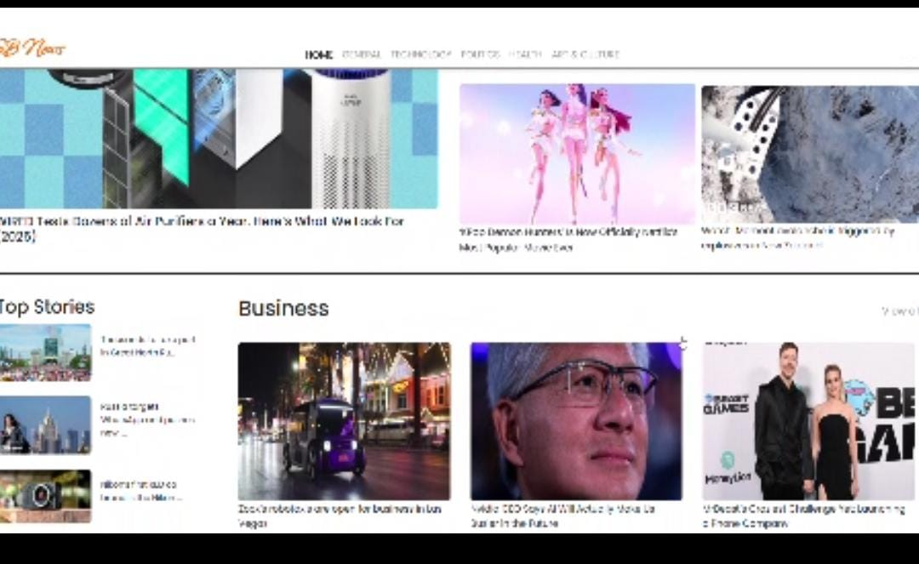

​**12. Known Issues**

- Connection Errors

- Redis Connection Errors: Check Redis status using docker logs insightstream-redis and redis-cli ping.

- MongoDB Connection Issues: Verify MongoDB status with docker logs insightstream-mongodb and mongosh --host localhost:27017.

- OpenAI API Issues: Test your API key to resolve issues.

- Streaming Issues

- Buffering and Lag: Insufficient bandwidth, network congestion, or outdated hardware/software can cause these issues.

- Audio Sync Issues: Poor internet connection, outdated software, or hardware limitations can lead to desynchronization.

- Session Timeouts: Extended pauses or multiple devices logged into the same account can trigger timeouts.

- Account and Subscription Issues

- Forgotten Login Credentials: Most platforms offer password recovery processes.

- Expired Subscriptions: Regularly check billing information to prevent service disruptions.

- Device and Browser Issues

- Device Compatibility: Outdated devices or software can lead to compatibility problems.

- Browser Issues: Browser extensions, cache, and cookies can affect streaming performance.¹ ²

- Security Concerns

- Data Privacy: Streaming services may track viewing habits and share data with third parties.

- Unsecured Networks: Public Wi-Fi networks can expose sensitive information.

To troubleshoot issues with InsightStream, check the official documentation, and support resources for specific solutions.

​**13. Future Enhancement**

InsightStream may involve³:

- Digital Skill Enhancement: Providing resources and training for students and professionals to develop future-ready skills, such as AI, data analytics, digital marketing, coding, and cybersecurity.

- Personalized Learning Experiences: Utilizing AI-powered tools to offer customized learning paths and real-time feedback.

- Enhanced Collaboration Tools: Developing features that facilitate seamless integration with existing systems and tools, enabling efficient collaboration and workflow management